1. Basic script

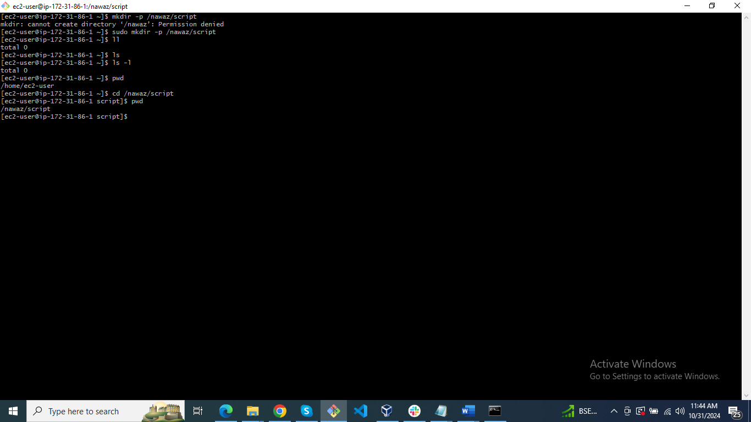

#!/bin/bash

#Purpose:To print Hellow

#Modified Date:10/31/2024

a='Hellow'

echo

echo $a

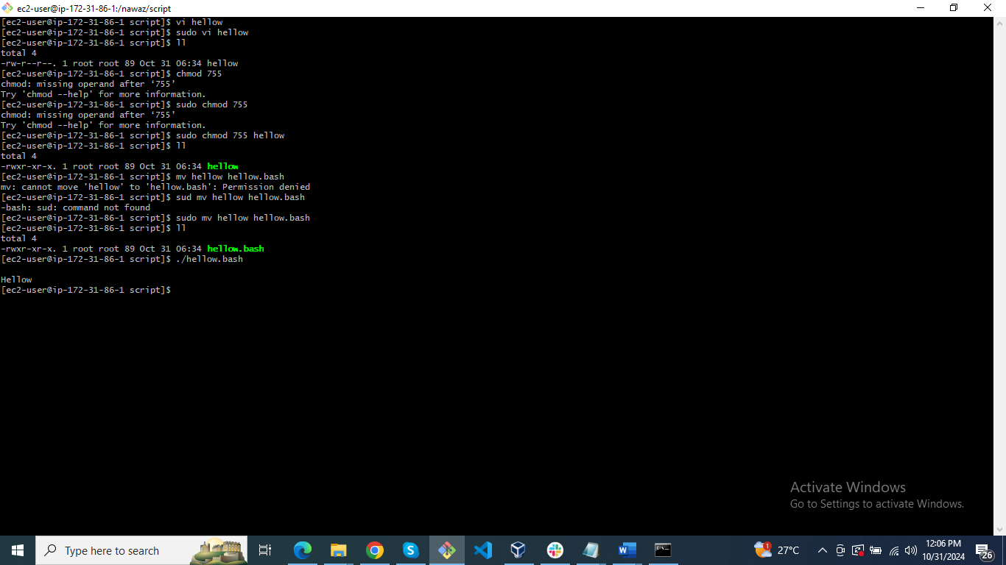

1. Basic Script

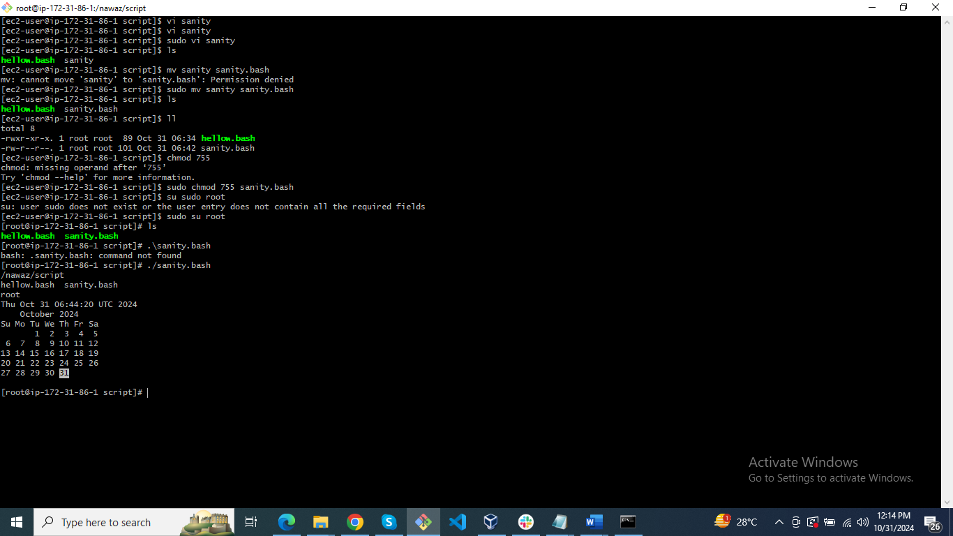

1. Basic script

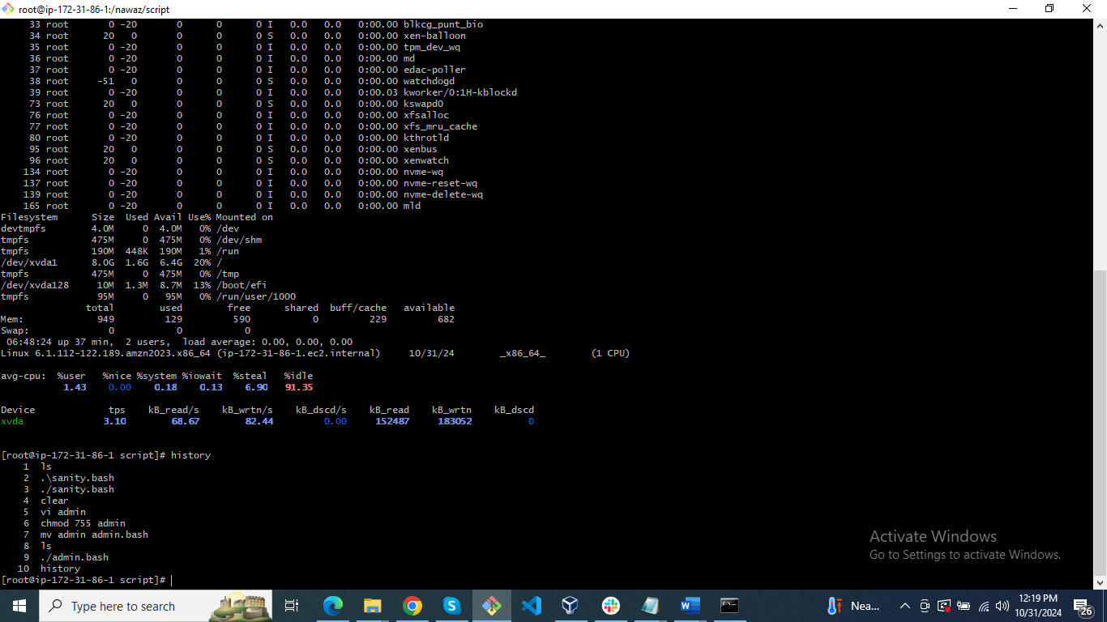

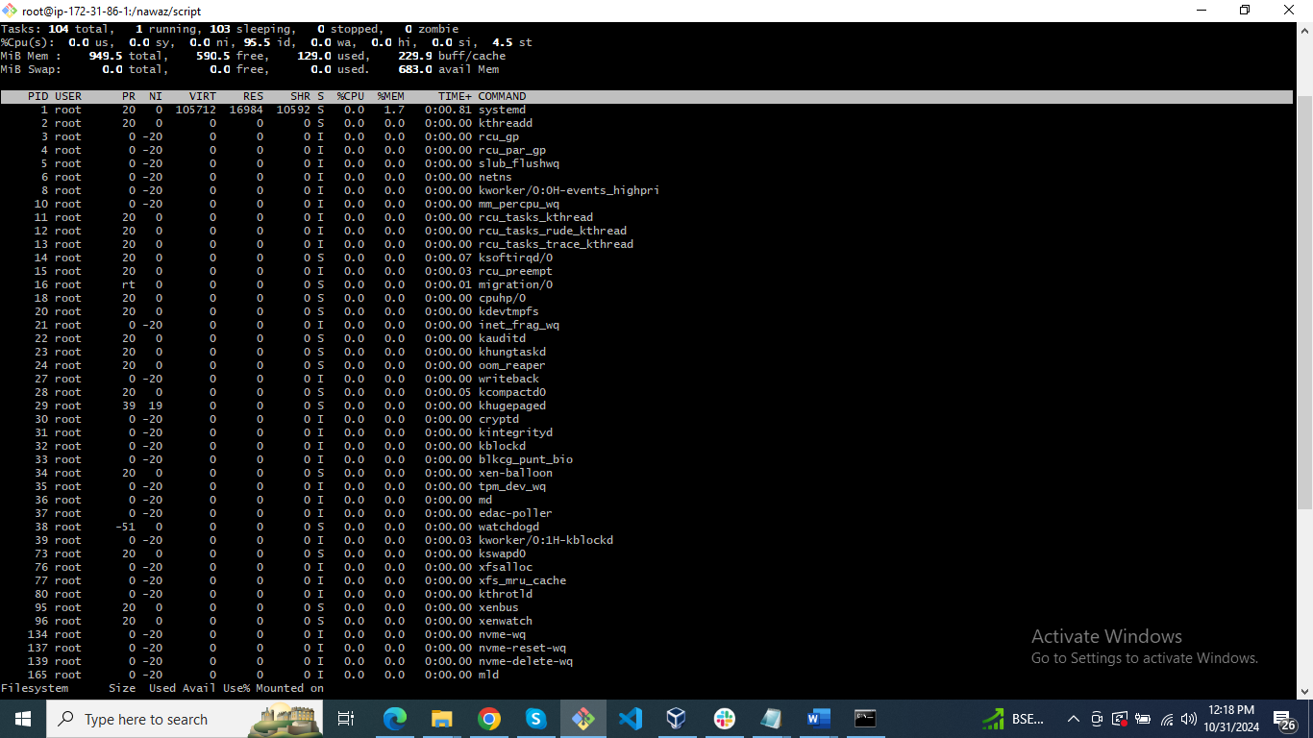

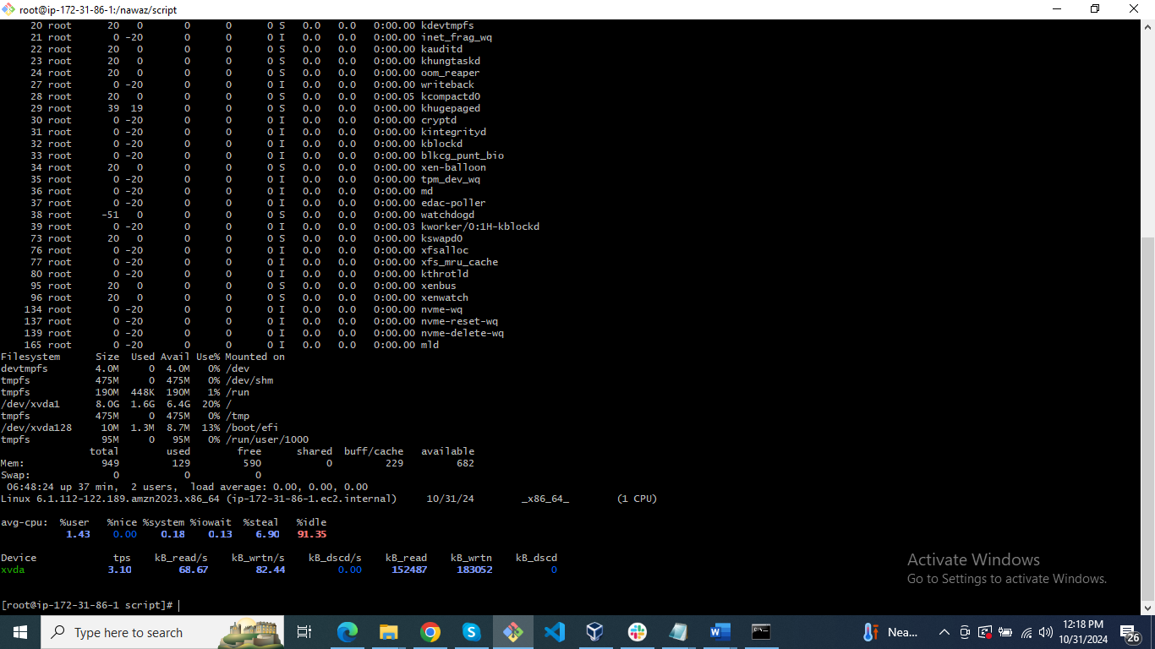

1. Scripts

Define Variables

p=pwd

l=ls

wi=whoami

d=date

c='cal 2024'

echo Run variables tasks

echo

$p

$l

$wi

$d

$c

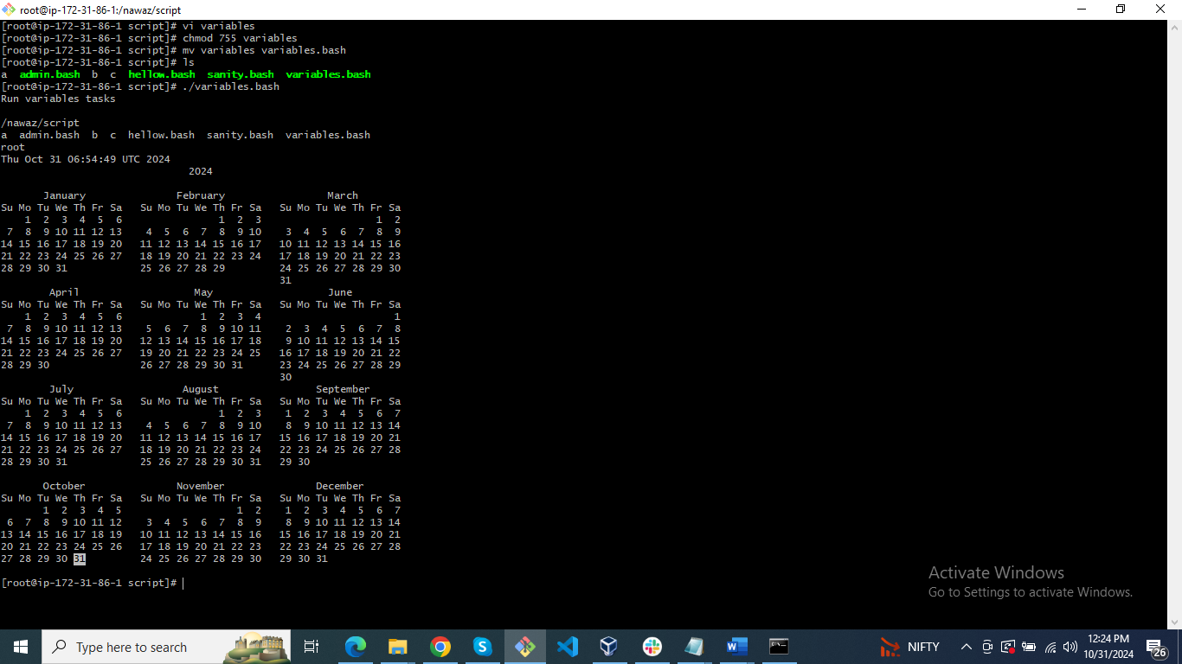

1. Input and output scripts

#!/bin/bash

#Purpose: Inbut and output for name

a=hostname

echo Hello, my name is $a

echo

echo what is your name?

read b

echo hello $b

echo

